7- Selenium

Wait Methods

Synchronization
Synchronization is the process of handling the time gap between Selenium commands and web application responses so that Selenium waits until elements are ready.

Common Exceptions Related to Synchronization
- NoSuchElementException
  - Element is not present on the page at that time
  - Usually occurs due to synchronization issues
- ElementNotFoundException
  - Locator is incorrect
  - Issue is with syntax or wrong code

Thread.sleep()
- Available in Java
- Time is given in milliseconds
- 1000 ms = 1 second
Advantages
- Easy to use
Disadvantages
- If time is not sufficient, exception occurs
- Always waits for maximum time, even if element loads early
- Reduces script performance
- Not reusable; needs to be written multiple times

public static void main(String[] args) throws InterruptedException {

WebDriver driver=new ChromeDriver();

driver.get("https://opensource-demo.orangehrmlive.com/web/index.php/auth/login");

Thread.sleep(10000);
driver.findElement(By.xpath("//input[@placeholder='Username']")).sendKeys("Admin");

}

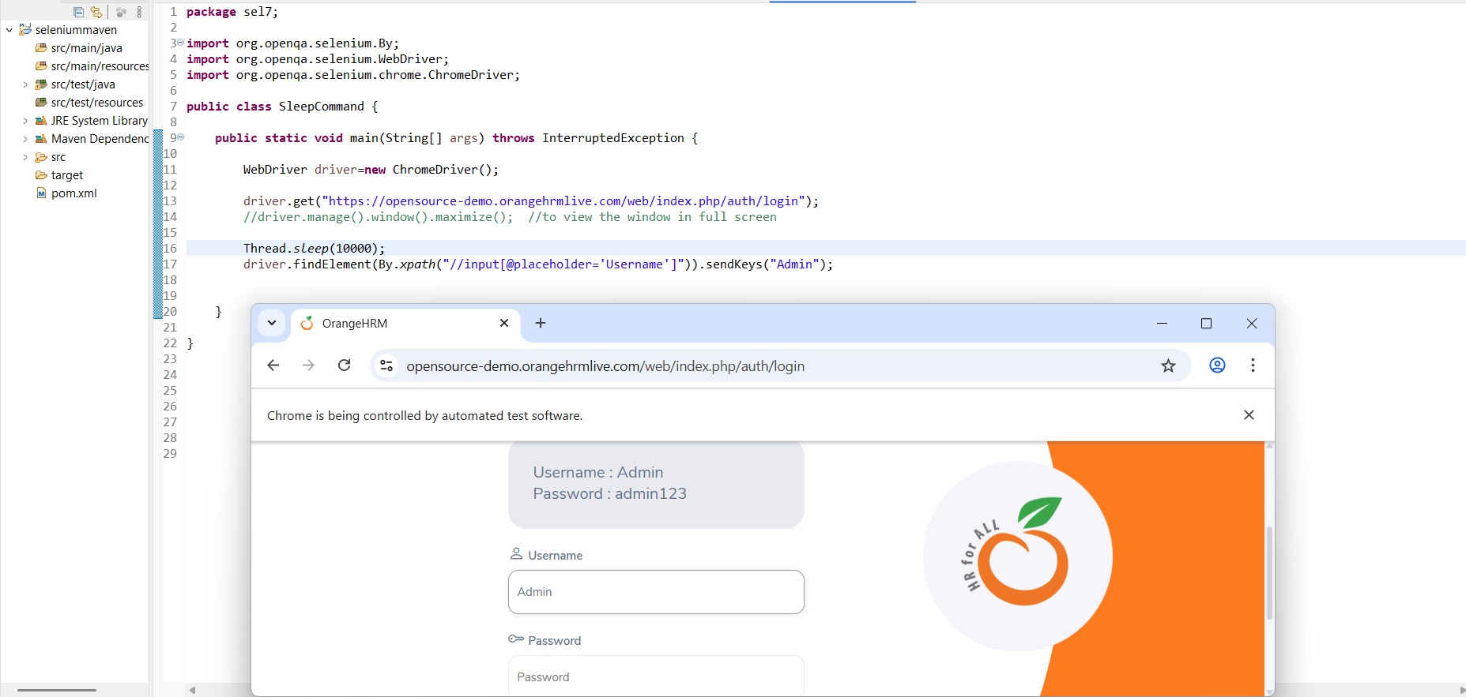

Implicit Wait
driver.manage().timeouts().implicitlyWait(Duration.ofSeconds(10));
Key Points
- Default timeout value is 0 seconds
- Applicable for all elements
Advantages
- Single statement (written only once)
- Does not wait till maximum time if element is available early
- Works globally for all elements
- Easy to use
Disadvantages
- If timeout is insufficient, exception occurs

public static void main(String[] args) {

WebDriver driver=new ChromeDriver();
driver.manage().timeouts().implicitlyWait(Duration.ofSeconds(10));

driver.get("https://opensource-demo.orangehrmlive.com/web/index.php/auth/login");

driver.findElement(By.xpath("//input[@placeholder='Username']")).sendKeys("Admin");

}

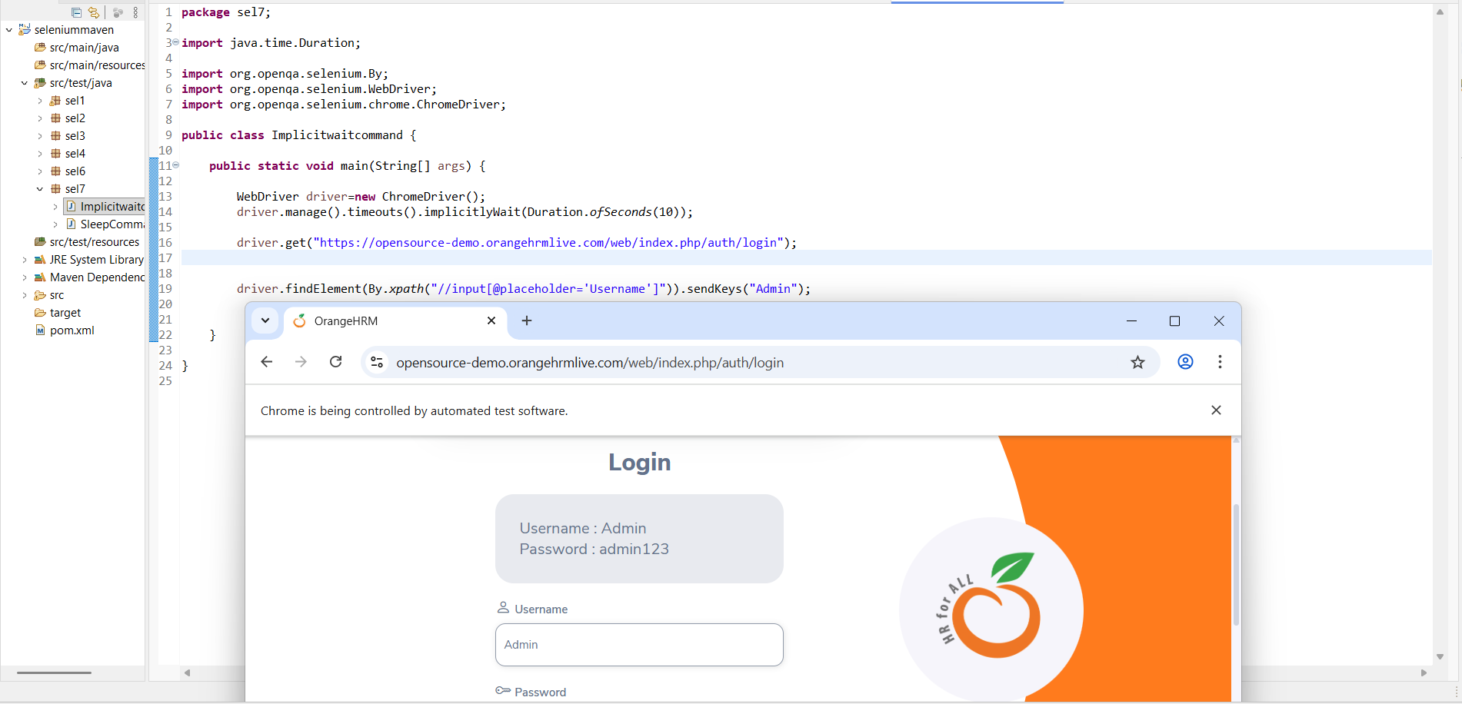

Explicit Wait
Works based on time + condition
Concept
- Selenium waits until a specific condition becomes true
- More effective than implicit wait
Important Points
- Condition-based waiting
- findElement() / findElements() are not required explicitly
- Waits only until condition is satisfied
- Multiple elements require multiple wait statements

Common Explicit Wait Conditions
- alertIsPresent()
- elementSelectionStateToBe()
- elementToBeClickable()
- elementToBeSelected()
- frameToBeAvailableAndSwitchToIt()
- presenceOfAllElementsLocatedBy()
- presenceOfElementLocated()
- textToBePresentInElement()
- textToBePresentInElementLocated()
- textToBePresentInElementValue()
- titleIs()
- titleContains()
- visibilityOf()
- visibilityOfAllElements()
- visibilityOfAllElementsLocatedBy()
- visibilityOfElementLocated()
Note
- It is not recommended to use explicit wait for multiple elements on the same page
- Prefer using explicit wait for one critical element per page

public static void main(String[] args) {

WebDriver driver=new ChromeDriver();

//Explicit wait declaration
WebDriverWait mywait=new WebDriverWait(driver,Duration.ofSeconds(10));

driver.get("https://opensource-demo.orangehrmlive.com/web/index.php/auth/login");

//usage of explicit wait
WebElement textusername=mywait.until(ExpectedConditions.visibilityOfElementLocated(By.xpath("//input[@placeholder='Username']")));
textusername.sendKeys("Admin");

WebElement textpwd=mywait.until(ExpectedConditions.visibilityOfElementLocated(By.xpath("//input[@placeholder='Password']")));
textpwd.sendKeys("admin123");

WebElement loginButton=mywait.until(ExpectedConditions.elementToBeClickable(By.xpath("//button[normalize-space()='Login']")));
loginButton.click();
}

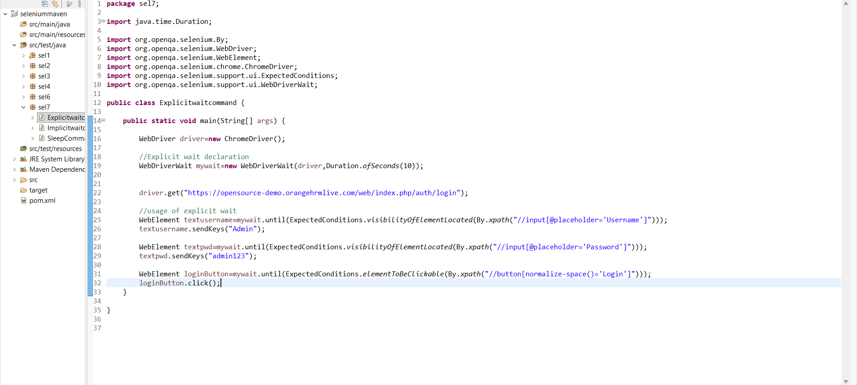

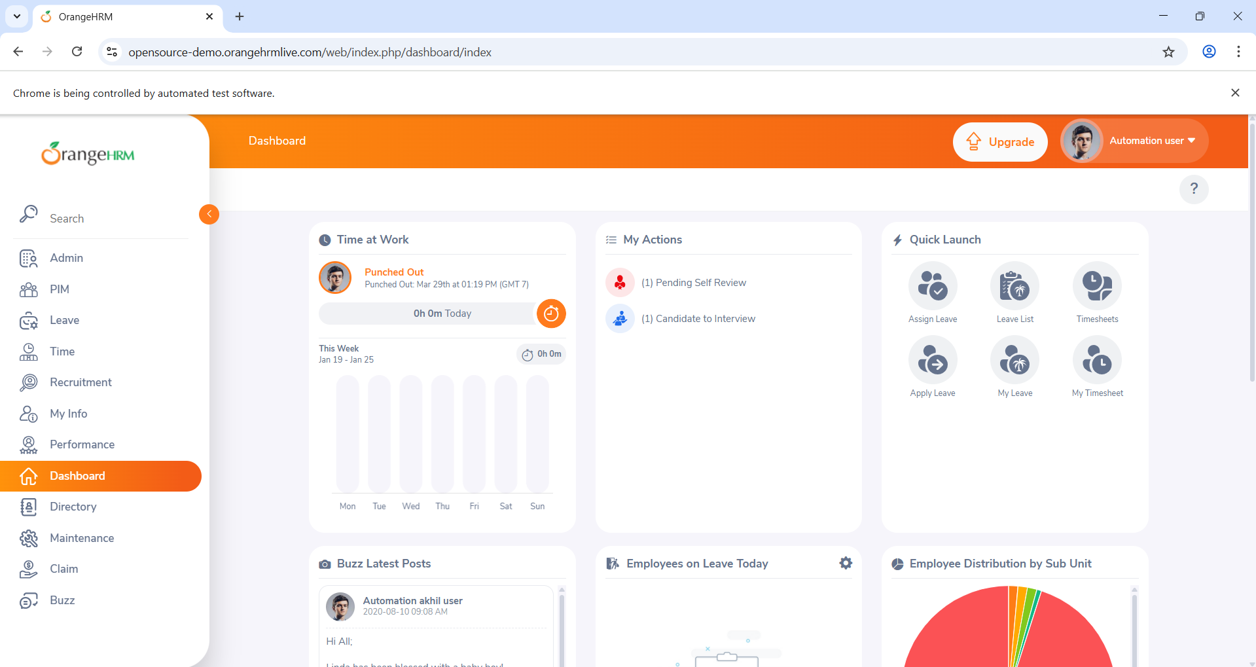

Fluent Wait
- Advanced version of explicit wait
- Allows:
  - Custom timeout
  - Polling frequency
  - Ignoring specific exceptions
Syntax
Wait<WebDriver> wait = new FluentWait<WebDriver>(driver)
.withTimeout(Duration.ofSeconds(time))
.pollingEvery(Duration.ofSeconds(time))
.ignoring(NoSuchElementException.class);

WebElement foo = wait.until(d ->
d.findElement(By.id("foo"))
);

public static void main(String[] args) {

WebDriver driver = new ChromeDriver();

// 1️ Open the application
driver.get("https://opensource-demo.orangehrmlive.com/web/index.php/auth/login");

// 2️ Declare FluentWait
Wait<WebDriver> mywait = new FluentWait<WebDriver>(driver)
.withTimeout(Duration.ofSeconds(10))
.pollingEvery(Duration.ofSeconds(2))
.ignoring(NoSuchElementException.class);

// 3️ Use FluentWait
WebElement txtUsername = mywait.until(new Function<WebDriver, WebElement>() {
public WebElement apply(WebDriver driver) {
return driver.findElement(By.xpath("//input[@placeholder='Username']"));
}
});

txtUsername.sendKeys("Admin");
}

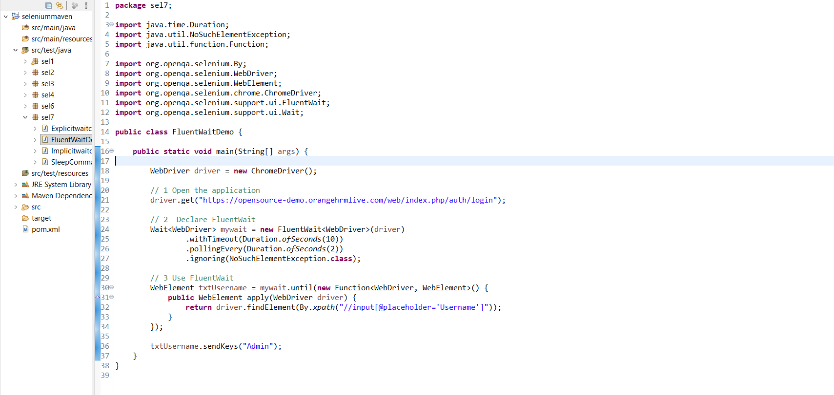

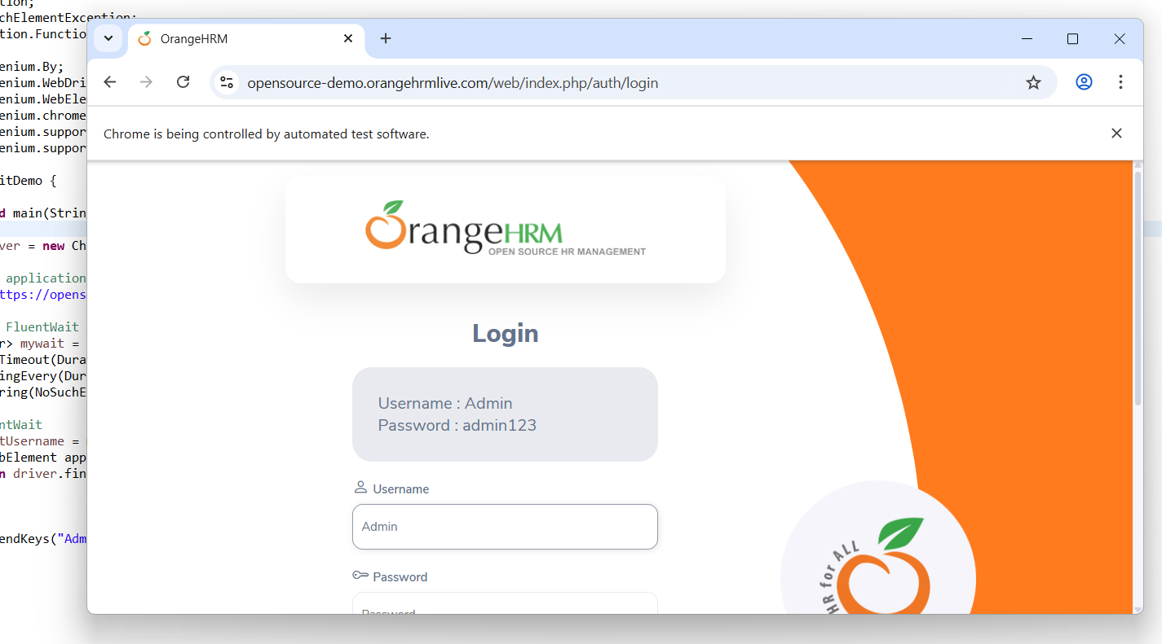

Page Load Timeout
driver.manage().timeouts().pageLoadTimeout(Duration.ofSeconds(5));
- Waits until the entire page is loaded

public static void main(String[] args) {

WebDriver driver=new ChromeDriver();
driver.manage().timeouts().pageLoadTimeout(Duration.ofSeconds(35));

driver.get("https://opensource-demo.orangehrmlive.com/web/index.php/auth/login");
driver.manage().window().maximize();

driver.findElement(By.xpath("//input[@placeholder='Username']")).sendKeys("Admin");

}

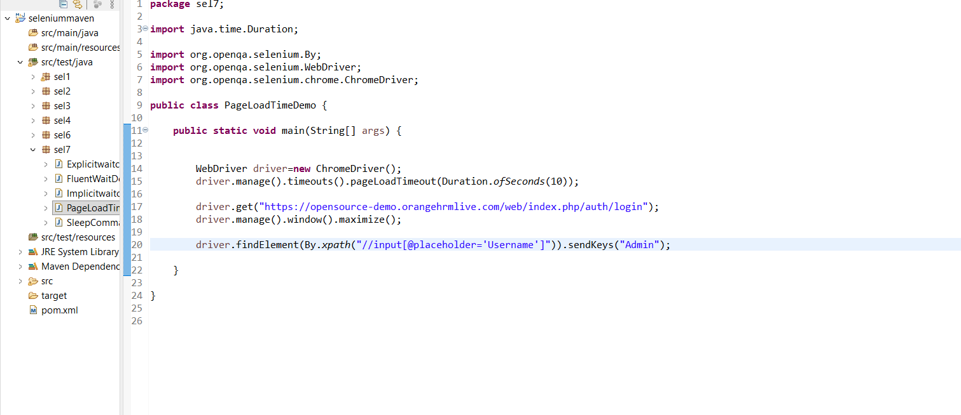

Important Notes & Best Practices
- Most preferred order:
  - Implicit Wait
  - Explicit Wait
  - Fluent Wait (least preferred due to inconsistency)
- NoSuchElementException should be handled using try-catch blocks
- Using multiple waits together is not useful
  - Example:
    - Implicit wait = 10 sec
    - Explicit wait = 10 sec
→ Selenium still waits only 10 seconds, not 20
- If:
  - Implicit = 10 sec
  - Explicit = 5 sec
→ Total wait will be 10 seconds
- If:
  - Implicit = 5 sec
  - Explicit = 10 sec
→ Total wait will be 10 seconds
➡️ Maximum timeout always dominates
Summary:
Synchronization in Selenium is handled using waits to ensure elements are available before performing actions, preventing NoSuchElementException.

